**1.What are the four important <meta> tags we use in SEO?**

There are several <meta> tags that can be used in SEO, but the four most important ones are:

1. Title tag: This tag specifies the title of a webpage and is displayed in the search engine results pages (SERPs). It should be concise, descriptive, and relevant to the content on the page. The title tag should also include the primary keyword that the page is targeting.
2. Description tag: This tag provides a brief summary of the content on the page and is also displayed in the SERPs. It should be compelling and encourage users to click through to the page. The description tag should also include the primary keyword and related keywords that the page is targeting.
3. Keyword tag: This tag used to be important for SEO, but it has lost its significance over time. The keyword tag specifies the primary keywords that the page is targeting, but search engines now rely more on the content of the page to determine its relevance to a particular search query.
4. Robots tag: This tag specifies whether search engines should index the page, follow the links on the page, or both. It can be used to prevent duplicate content from being indexed, block search engines from indexing sensitive content, or prevent pages from being crawled altogether.

It's important to note that while these <meta> tags can help to optimize a webpage for search engines, they are not the only factors that affect SEO. Other important factors include the quality and relevance of the content on the page, the website's overall structure and usability, and the quality and quantity of backlinks pointing to the page.

**2. What is the use of open-graph tags in a website?**

Open Graph tags are a type of metadata that can be added to a webpage’s HTML code to provide information about the page’s content when it is shared on social media platforms, such as Facebook or Twitter. These tags include information such as the page’s title, description, and image, which can help to make the shared content more visually appealing and informative for users. By using Open Graph tags, website owners can control how their content appears when it is shared on social media, which can increase the chances of their content being clicked on and shared by others. [1][2][3][4]

Sources:

<https://ahrefs.com/blog/open-graph-meta-tags/>

<https://www.freecodecamp.org/news/what-is-open-graph-and-how-can-i-use-it-for-my-website/>

<https://www.pagecloud.com/blog/how-to-add-open-graph-tags>

<https://www.webdevsplanet.com/post/how-to-add-open-graph-in-a-website>

**3.What tag we will use to add an image to the website? Explain the points we should care about while adding the image to the website.**

The `<img>` tag is used to add an image to a website.

Here are some points to keep in mind when adding an image to a website:

1. File size: Images should be optimized for the web to ensure fast loading times. Large images can slow down the loading time of a webpage, which can lead to a poor user experience.
2. Image format: JPEG and PNG are the most commonly used formats for web images. JPEG is best for photographs and complex images, while PNG is best for simple images with transparency.
3. Alt text: The alt attribute should be added to the `<img>` tag to provide a description of the image for screen readers and search engines.
4. Image dimensions: The width and height attributes should be added to the `<img>` tag to specify the dimensions of the image. This helps the browser to load the page faster, as it knows the exact space required for the image.
5. Placement: Images should be placed appropriately within the content to make the page visually appealing and to enhance the user experience.
6. Copyright: Make sure you have the legal rights to use the image, or have obtained it from a source that allows free use, such as a public domain or a creative commons license. It is important to give credit to the original source if required.

**4. What is the difference between NOFOLLOW and NOINDEX?**

`NOFOLLOW` and `NOINDEX` are two different meta tags used in HTML to provide instructions to search engines on how to handle a particular page or link. Here are the differences between the two:

1. `NOFOLLOW`: The `NOFOLLOW` tag is used to instruct search engines not to follow a particular link on a webpage. This means that the link will not be considered in the search engine’s ranking algorithm and will not contribute to the page’s search engine optimization (SEO).
2. `NOINDEX`: The `NOINDEX` tag is used to instruct search engines not to index a particular page on a website. This means that the page will not appear in search engine results pages (SERPs) and will not contribute to the website’s SEO.

In summary, `NOFOLLOW` is used for individual links, while `NOINDEX` is used for entire pages. The former tells search engines not to pass authority from one page to another, while the latter tells them not to include a page in search results.

**5.Explain the types of queries.**

In the context of databases, there are three main types of queries:

1. Select Queries: A select query is used to retrieve data from one or more tables in a database. It is the most common type of query and is used to fetch data from a database based on specific criteria such as filtering, sorting, and aggregating.
2. Insert Queries: An insert query is used to insert new data into a table in a database. It is used to add new records to a table, and it can insert data into specific columns or all the columns in a table.
3. Update Queries: An update query is used to modify existing data in a table in a database. It is used to change the values of one or more columns in an existing row, or update multiple rows at once based on specific criteria.

In addition to these three main types of queries, there are also other types of queries such as:

1. Delete Queries: A delete query is used to remove one or more records from a table in a database.
2. Join Queries: A join query is used to retrieve data from multiple tables in a database based on some condition that matches the records in the tables.
3. Subquery: A subquery is a query nested within another query. It can be used to retrieve data that will be used in a main query, or to filter the results of a main query based on specific criteria.
4. Aggregate Queries: Aggregate queries are used to perform calculations on groups of records in a table. Common examples include calculating the sum, average, or count of records in a table.

**6.What is the importance of Site Map and Robot.txt in SEO?**

Both Site Map and Robots.txt are important tools in SEO for different reasons. Here’s a brief overview of each:

1. Sitemap: A sitemap is a file that provides a map of a website’s pages, posts, and other content. It helps search engines to crawl and index a website’s pages more effectively.

By providing a sitemap, you can ensure that search engines can easily find and crawl all of your website’s content, regardless of the internal linking structure. This can help improve the visibility and ranking of your website in search engine results pages (SERPs).

1. Robots.txt: Robots.txt is a file that provides instructions to search engine bots on which pages and files should be crawled or excluded from crawling. It can be used to prevent certain pages or sections of a website from being indexed in search engines.

By using robots.txt, you can prevent search engines from indexing content that you don’t want to appear in search results, such as duplicate content, private pages, or sensitive information. This can help improve the relevancy and accuracy of search results.

In summary, a sitemap helps search engines to crawl and index your website more effectively, while robots.txt helps you to control which pages are indexed and excluded from indexing. Both of these tools are important for effective SEO and should be used together to improve the overall visibility and ranking of your website.

**7.Below is the list of pages for an e-commerce site that doesn’t need to be crawled by any crawler.**

**o Admin pages**

**o Cart page**

**o Thank-you page**

**o Images**

**How will you achieve this?**

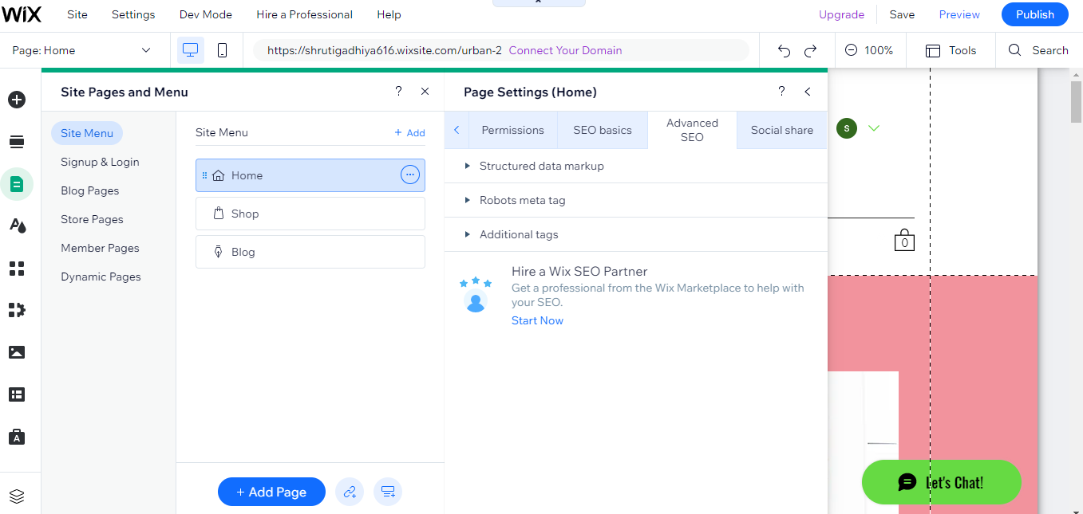

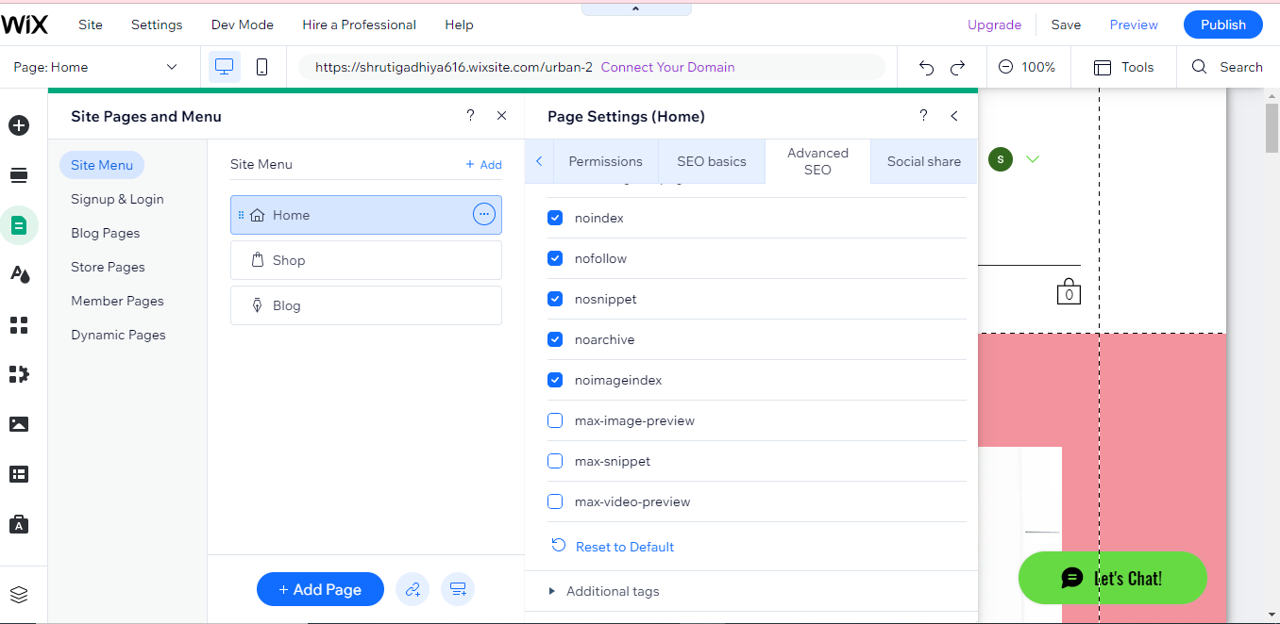

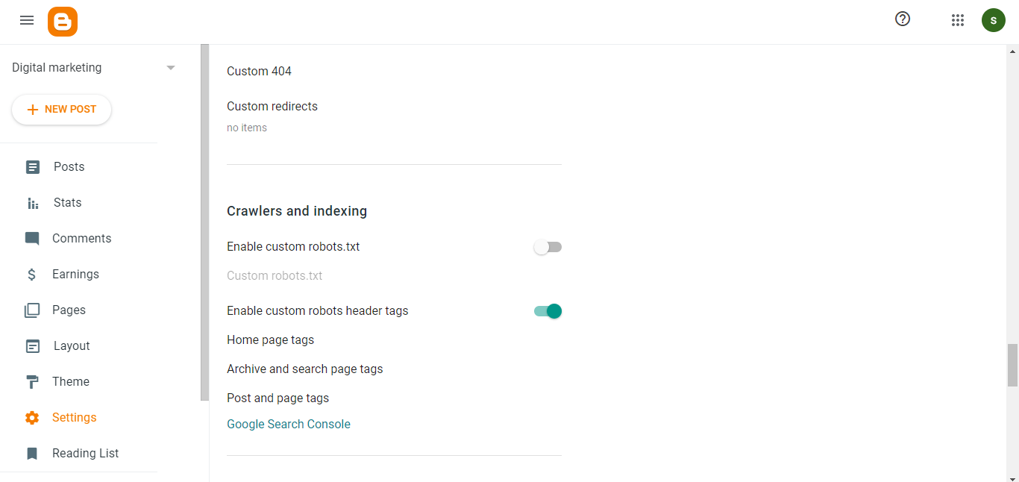

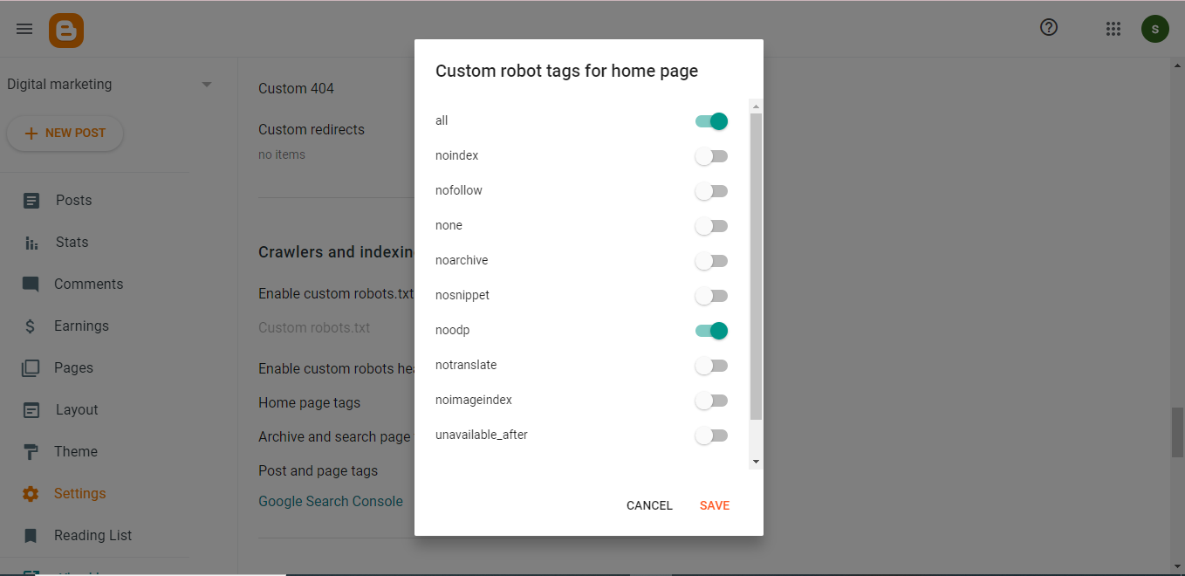

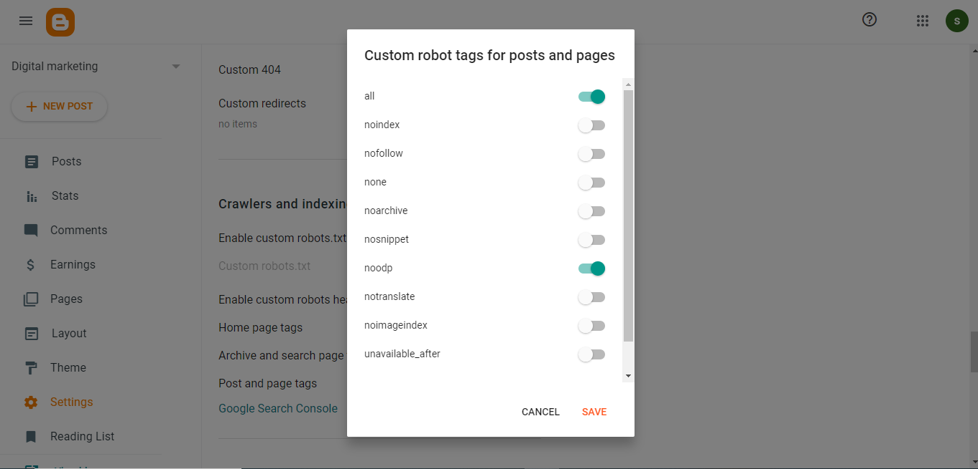



**8. What are on-page and off-page optimization?**

On-page optimization and off-page optimization are two main types of Search Engine Optimization (SEO) techniques that are used to improve the ranking and visibility of a website in search engine results pages (SERPs). Here is a brief overview of each:

1. **On-page optimization:** On-page optimization refers to the process of optimizing individual web pages in order to improve their relevance to specific keywords and topics. It includes various elements such as optimizing the content of the webpage, its structure, the HTML code, and the meta tags.

On-page optimization techniques can help search engines to understand the content of a webpage, improve its relevance to specific keywords, and make it easier for users to find relevant information. Some common on-page optimization techniques include optimizing title tags, meta descriptions, header tags, URL structure, and internal linking.

1. **Off-page optimization:** Off-page optimization refers to the process of improving a website’s authority and reputation by getting external links pointing to it from other high-quality websites. Off-page optimization is mostly concerned with link building and social media marketing.

Off-page optimization techniques aim to improve a website’s visibility and ranking by establishing the website as a valuable and reputable source of information. Some common off-page optimization techniques include guest blogging, social bookmarking, directory submission, and social media marketing.

Both on-page and off-page optimization techniques are essential to achieving high search engine rankings and driving organic traffic to a website. A well-executed SEO strategy should include a combination of both on-page and off-page optimization techniques to achieve the best possible results.

**9,Perform an on-page SEO using available tools for** [**https://www.tops-int.com/it-training-rajkot**](https://www.tops-int.com/it-training-rajkot)

* **Best digital marketing course in rajkot**

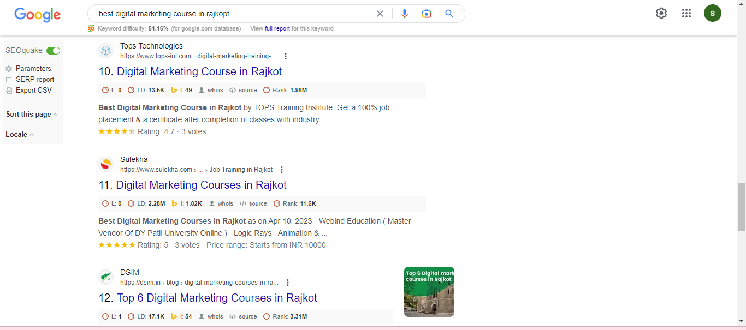

* **Best training institute Rajkot**

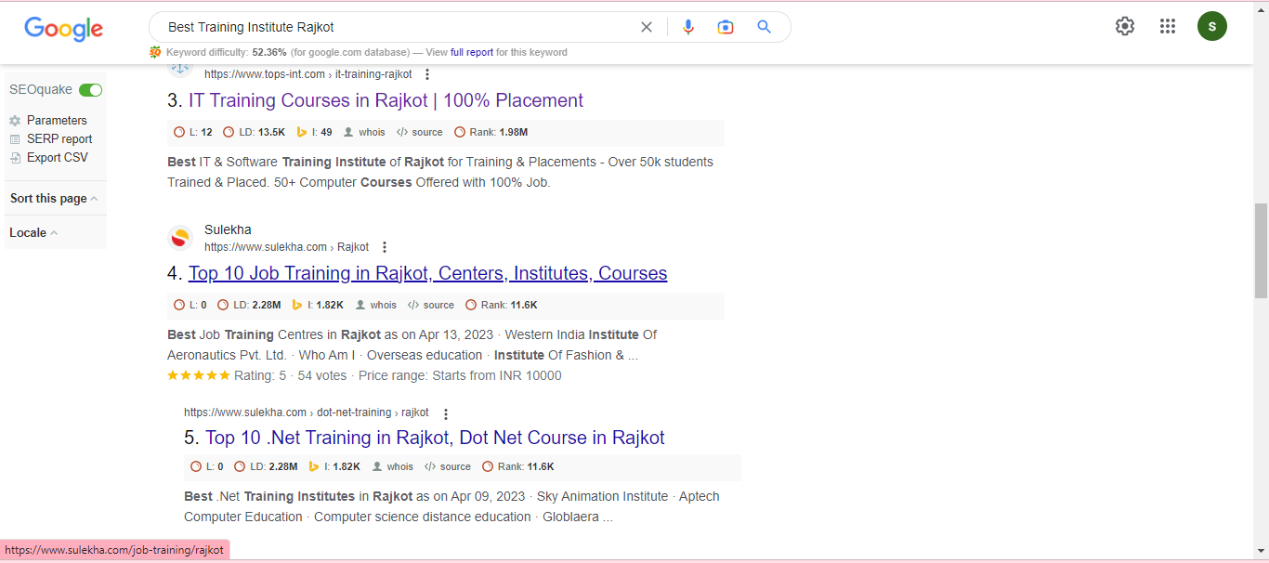

* **Ios training in Rajkot**

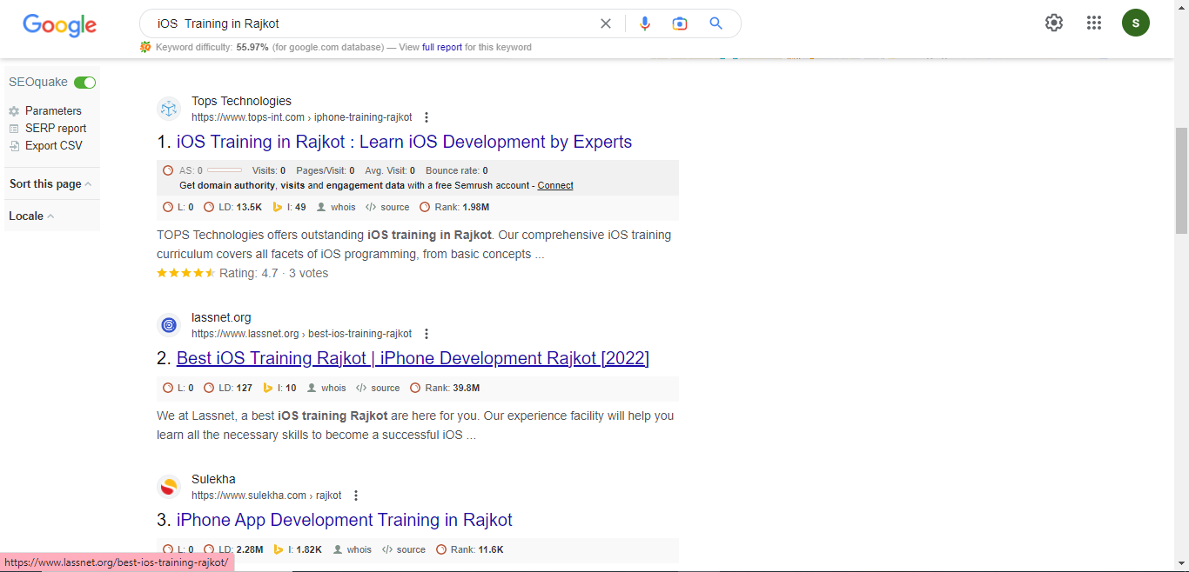

* **Python training in Rajkot**

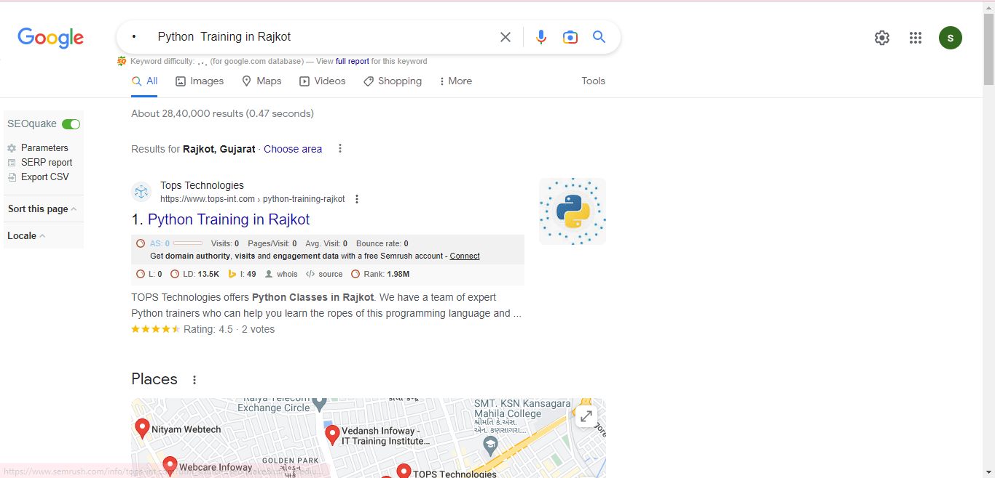

**10. Prepare complete on-page and off-page SEO audit report for** [**www.esellerhub.com**](http://www.esellerhub.com)**.**

**As an AI language model, I am not able to access and analyze websites in real-time. However, I can provide you with a general outline of what a complete on-page and off-page SEO audit report might include for www.esellerhub.com.**

**On-page SEO Audit Report:**

**1. Title Tags: Ensure that each page has a unique and descriptive title tag that accurately reflects the content of the page.**

**2. Meta Descriptions: Ensure that each page has a unique and compelling meta description that includes relevant keywords and encourages users to click through to the page.**

**3. Headings: Check that each page has proper heading tags (H1, H2, H3, etc.) and that they are used in a logical and hierarchical manner.**

**4. Content Quality: Analyze the content on each page for quality, relevance, and uniqueness. Make sure the content is engaging and provides value to the user.**

**5. Keyword Usage: Check that each page includes relevant keywords throughout the content, but avoid keyword stuffing.**

**6. Internal Linking: Check that there are internal links between pages and that they are using descriptive anchor text.**

**7. Images: Check that all images have proper alt tags and are optimized for web use.**

**8. Mobile Friendliness: Check that the website is mobile-friendly and that the content is easy to read and navigate on a mobile device.**

**9. Page Speed: Analyze the website's page speed and identify any areas where it can be improved.**

**Off-page SEO Audit Report:**

**1. Backlinks: Analyze the website's backlink profile and identify any low-quality or spammy links that could be harmful to the website's SEO.**

**2. Social Media: Check that the website has a presence on relevant social media platforms and that they are regularly posting and engaging with users.**

**3. Local SEO: Check that the website is optimized for local search by including relevant business information and local keywords.**

**4. Brand Reputation: Monitor the website's online reputation by analyzing customer reviews, mentions, and feedback on social media and other review sites.**

**5. Competitor Analysis: Analyze the website's competitors and identify areas where they are performing well in terms of SEO and digital marketing.**

**6. Content Marketing: Check that the website is regularly producing high-quality content that is shareable and engaging to users.**

**7. Analytics: Monitor website analytics to identify trends and areas where the website can be improved in terms of traffic, engagement, and conversions.**

**These are just some of the key areas that could be included in a complete on-page and off-page SEO audit report for www.esellerhub.com. It is important to note that every website is unique and may require a customized approach to SEO.**

**11. What are the characteristics of “bad links”?**

“Bad links” refer to links that are considered low-quality, spammy, or irrelevant by search engines, and can harm a website’s search engine ranking. Here are some of the characteristics of bad links:

1. Low authority websites: Links from websites with low domain authority, poor quality content, or those that have been penalized by search engines are considered bad links.
2. Irrelevant or spammy websites: Links from websites that are not related to the website’s niche or industry and have poor quality content or spammy characteristics are also considered bad links.
3. Paid links: Links that have been purchased for the purpose of manipulating search engine rankings are considered bad links and can result in penalties from search engines.
4. Link farms and spam directories: Links from link farms or spam directories, which are created solely for the purpose of linking to other websites, are considered bad links.
5. Comment spam and forum signatures: Links that are added to comment sections or forum signatures without adding any value or relevance to the conversation are considered bad links.
6. Over-optimized anchor text: Links that use over-optimized anchor text, such as using the exact match keyword repeatedly, are considered bad links and can result in penalties from search engines.
7. Links from malware or phishing websites: Links from websites that contain malware or phishing content are considered bad links and can harm the website’s reputation and ranking.

It is important to regularly monitor a website’s backlink profile and disavow any bad links that may harm its search engine performance.

**12. Perform Keyword Research then create a blog on “Importance of IT Training” and provide a link to TOPS Technologies and connect it with the webmaster and Google Analytics.**

[**https://dmrajkot.blogspot.com/2023/04/importance-of-it-training-it-training.html**](https://dmrajkot.blogspot.com/2023/04/importance-of-it-training-it-training.html)

**13What is the use of Local SEO?**

Local SEO (Search Engine Optimization) is the process of optimizing a website or online presence to improve its visibility and ranking in local search results. Local SEO is primarily used by businesses with a physical location or those serving a specific geographic area.

The primary goal of local SEO is to ensure that the business’s website or online presence appears at the top of local search results when users search for relevant keywords or phrases related to the business. This is important because many users rely on search engines to find local businesses and services.

Local SEO can be used to increase online visibility, attract more targeted traffic to a website, and generate more leads and conversions. Some of the benefits of local SEO include:

1. Increased visibility in local search results: Local SEO helps businesses appear at the top of local search results, which can increase their visibility and exposure to potential customers.
2. Improved website traffic: By appearing at the top of local search results, businesses can attract more targeted traffic to their website, which can lead to more leads and conversions.
3. More targeted leads: Local SEO can help businesses attract more targeted leads by optimizing their website for specific keywords and phrases related to their business and industry.
4. Enhanced online reputation: By optimizing their online presence, businesses can improve their online reputation and credibility, which can lead to more trust and confidence among potential customers.
5. Competitive advantage: Local SEO can give businesses a competitive advantage over their competitors by helping them stand out in local search results and attract more customers.

Overall, local SEO is an essential component of any local business’s online marketing strategy, as it can help them improve their online visibility, attract more targeted traffic, and generate more leads and conversions.